**KEERTHANA T**

**710719104053**

**Dr. N.G.P. INSTITUTE OF TECHNOLOGY**

**Screenshot :**

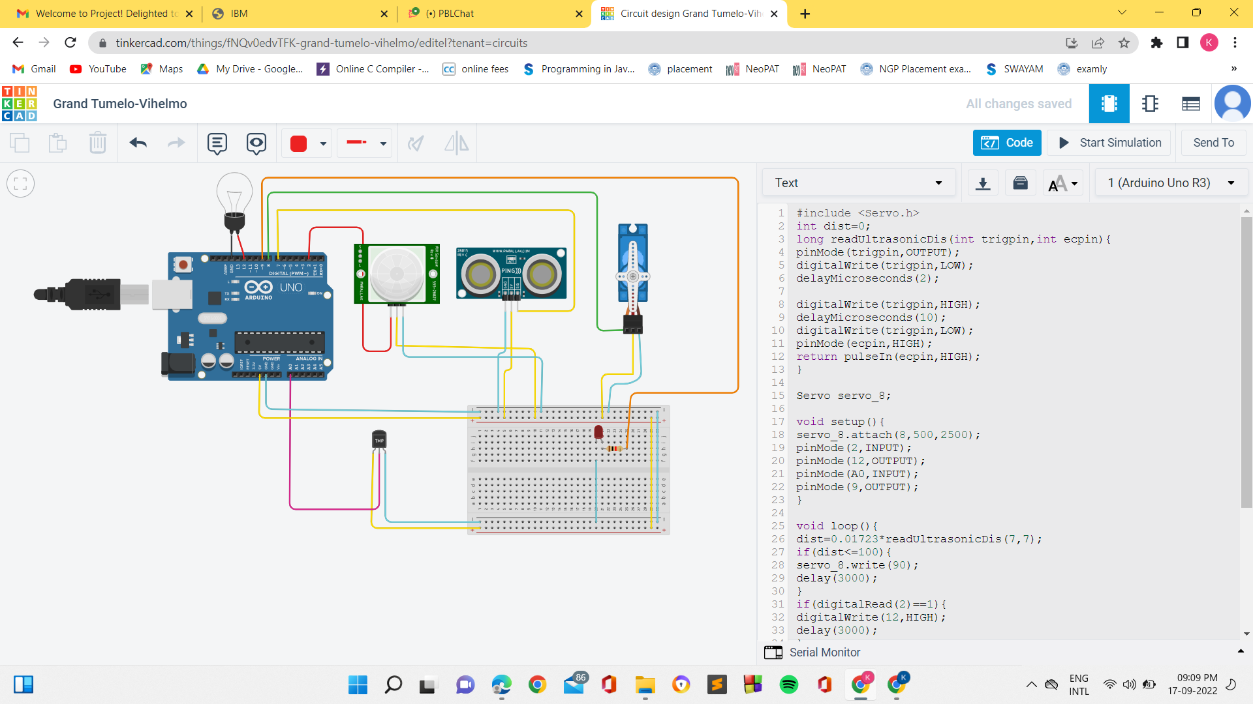

**Code:**

#include <Servo.h>

int dist=0;

long readUltrasonicDis(int trigpin,int ecpin){

pinMode(trigpin,OUTPUT);

digitalWrite(trigpin,LOW);

delayMicroseconds(2);

digitalWrite(trigpin,HIGH);

delayMicroseconds(10);

digitalWrite(trigpin,LOW);

pinMode(ecpin,HIGH);

return pulseIn(ecpin,HIGH);

}

Servo servo_8;

void setup(){

servo_8.attach(8,500,2500);

pinMode(2,INPUT);

pinMode(12,OUTPUT);

pinMode(A0,INPUT);

pinMode(9,OUTPUT);

}

void loop(){

dist=0.01723*readUltrasonicDis(7,7);

if(dist<=100){

servo_8.write(90);

delay(3000);

}

if(digitalRead(2)==1){

digitalWrite(12,HIGH);

delay(3000);

}

else{

digitalWrite(12,LOW);

delay(3000);

}

if(analogRead(A0)>200){

digitalWrite(9,HIGH);

delay(3000);

}

else{

digitalWrite(9,LOW);

delay(3000);

}

}